Sprint 3 retrospective

By Gerardo Flores, Ahram Kim – CCP Tour App

# Sprint demo

On this third sprint for our CCP Tour App, we redesigned icon and splash screen for the app and finished the ‘about’ tab to be presented for all information about CCP building, CS department, and self-guided..

# Definition of done

* Code builds without warnings
* Code unit tested
* All acceptance criteria have been met
  + We redesigned splash screen and icon.
  + We start and finish the ‘about’ tab for the user.
* We have tested to connect to Ionic framework and not found any defects
* All the automated tests for the user story run without failing and any defects
* Pair programming is done
* Build pushed to demo server

# Burndown chart and velocity

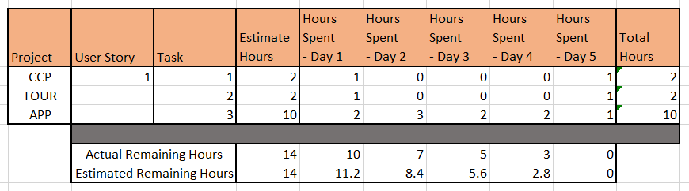

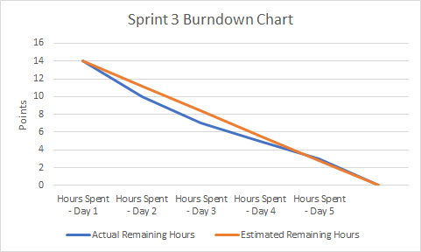

# Project Name: CCP TOUR APP

Team member (print/sign):_____Ahram Kim______________________________________________

Team member (print/sign):_____Gerardo Flores__________________________________________

Sponsor name (printed): Ashley Beasley

**Sponsor signature:** _________________________________________________________________________

Date: 10/16/2018

Sponsor checklist:

* I have seen the user stories completed demoed and they appear to work and meet the DOD
* Team has provided me with a burn down chart and velocity

